3.5.1 Ecercise

#1.facet a continuos variable

ggplot(data=mpg)+

geom_point(mapping=aes(x=displ,y=hwy))+

facet_wrap(~cty,nrow=2)

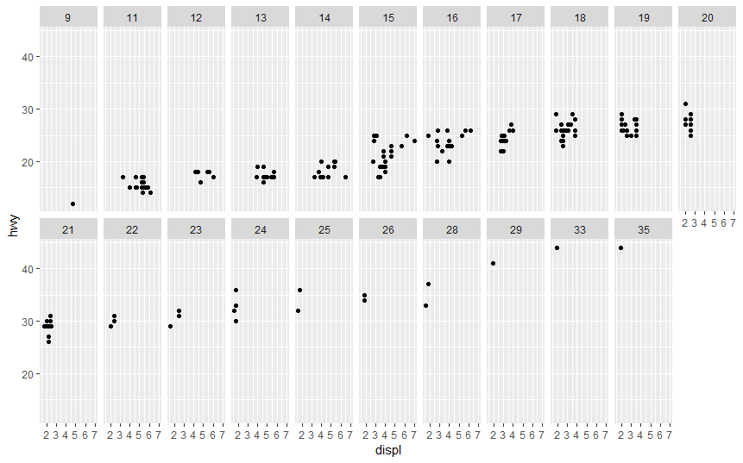

# Using a continous variable in a facet will lead many individual plots which may not be meaning.

# I would startify the continuos variable and tehn use is as a facet again to get more meaning

2.What do the empty cells in plot with facet_grid(drv ~ cyl) mean? How do they relate to this plot?

# Empty cell imply that for that very plot there are no points or characteristics of the cars that describes all the 4 quanties measured(no intersection)

ggplot(data = mpg) +

geom_point(mapping = aes(x = drv, y = cyl))

# They relate with this plot because when you look at the plot the some levels for cyl and drv that do not intersect at all.Which was reflected in the facet(drv~cyl)plot

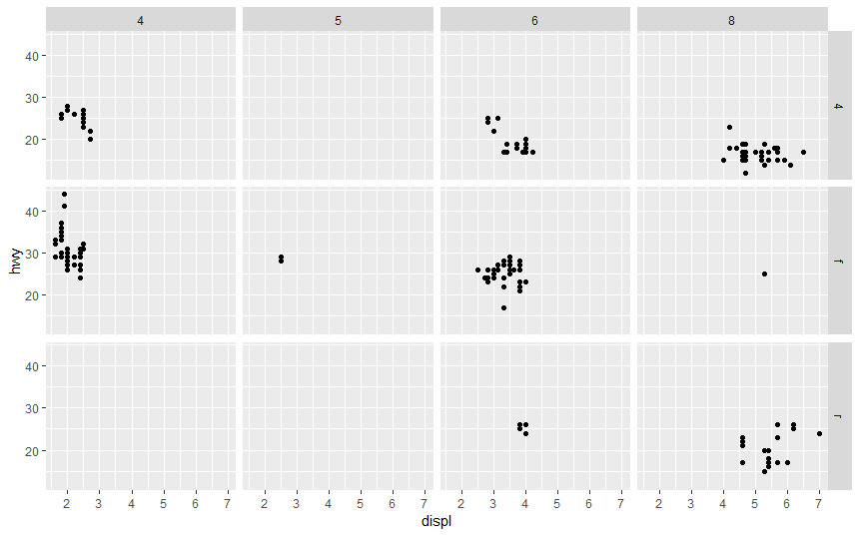

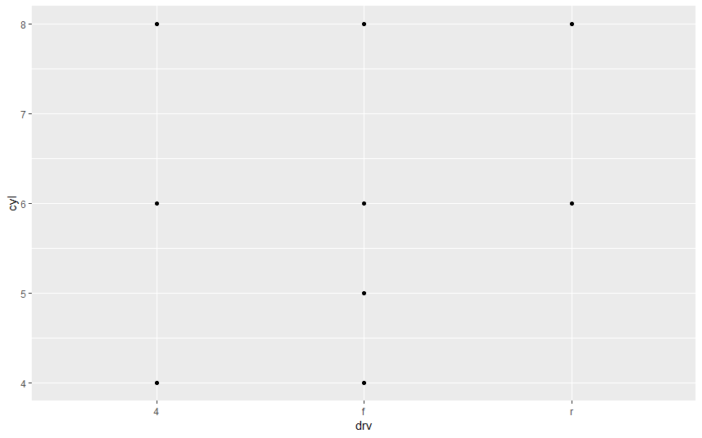

3. What plots does the following code make? What does . do?

ggplot(data = mpg) +

geom_point(mapping = aes(x = displ, y = hwy)) +

facet_grid(drv ~ .)

# The “attribute ~ dot” notation plots the attribute values without a column attribute, thus showing multiple row-wise plots for each attribute value.

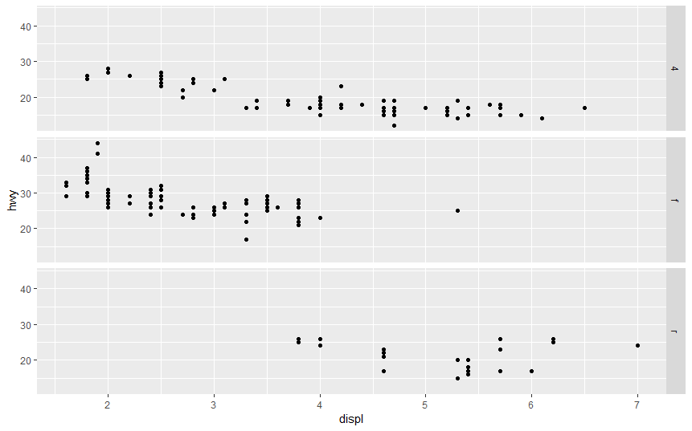

#4.Take the first faceted plot in this section:

ggplot(data = mpg) +

geom_point(mapping = aes(x = displ, y = hwy)) +

facet_grid(. ~ cyl)

#The y-axis is repeated. With “dot ~ attribute” the row attribute is missing, thus showing column-wise the plots. Then the x-axis is repeated.

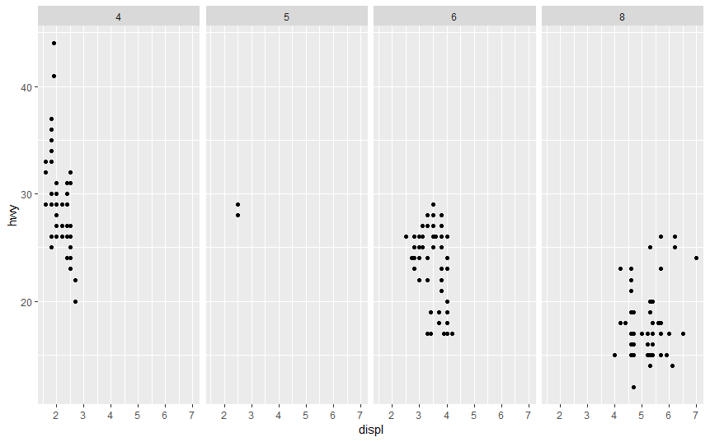

ggplot(data = mpg) +

geom_point(mapping = aes(x = displ, y = hwy,color=class)) +

facet_wrap(~ class, nrow = 2)

#What are the advantages to using faceting instead of the colour aesthetic?

#Faceting is very good for visualisning categorical variables. It gives a clear picture of what is happening in every category

#What are the disadvantages?

#facetting is not really good for continuous data types

#How might the balance change if you had a larger dataset?

#The color aesthetic is fine when your data set is small,but with larger data sets points may begin to overlap with one another.

5.Read ?facet_wrap. What does nrow do? What does ncol do?

?facet_wrap #nrow and ncol controls the number of rows and columns

#What other options control the layout of the individual panels?

#scales,shrink,labeller,as.table,switch,drop,dir,strip position.

#Why doesn’t facet_grid() have nrow and ncol arguments?

#Facet grids do not have these configuration because the rows and cols are determined by the specified attributes.

#6.When using facet_grid() you should usually put the variable with more unique levels in the columns. Why?

#When putting the more levels on the row axis, then the y-axis would shrink

#so that it is harder to see which actual values are at the points as shown in the plot.e.g

ggplot(data = mpg) +

geom_point(mapping = aes(x = displ, y = hwy)) +

facet_grid(class ~ drv)

